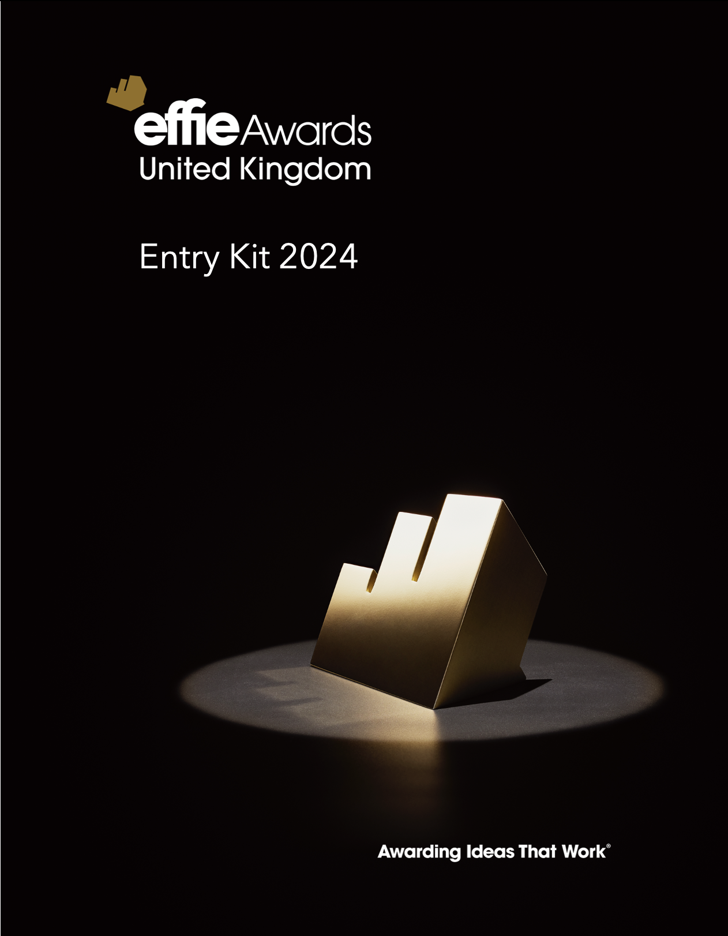

Introduction

This document is designed to give you all the information you need to write and submit your entry.
It includes all the practical stuff - like what work is eligible to enter, what categories are available, accepted creative assets & credits, how publication permissions work, how to source your data, etc. It also explains the Effie entry form section by section, to help you understand exactly what the judges are looking for. Plus, there’s information about what happens during judging and beyond. If you’d like us to send you any sections of this Entry Kit as separate documents, get in touch.
We’ve produced a separate Effective Entry Guide with tips and advice to help you write the best entry you can and maximise your chances of winning. And we also offer free online workshops and training that you can sign up for – you’ll find the links to these on our Awards website.
If you have any questions at any stage of the process, please ask and we'll be happy to help. Just email effieuk@effie.org
We wish you all the best in this year’s competition!
Effie UK


Contents

How to enter – page 3
  - Eligibility
  - Categories
  - Deadlines & Fees
  - How to pay
  - How to submit your entry
How to complete the entry form – page 11
  - Overview
  - Pillars 1- 4 of Effie’s Framework

How to make your entry compliant – page 17
  - Rules
  - Sourcing data
  - Creative Reel and Imagery
  - Publicity
  - Credits
  - Confidentiality & Publication

What happens next – page 28
  - Judging
  - If you win

Appendix– page 32
  - Categories in detail
  - Contact information

Click on each topic to link straight to the relevant page.


How to enter

Eligibility

ALL MARKETING ACTIVITY THAT RAN IN THE UNITED KINGDOM AT ANY POINT BETWEEN 1ST JULY 2022 AND 31ST DECEMBER 2023* IS ELIGIBLE TO ENTER.
Any and all marketing cases, from any discipline, whether full campaigns or specific activities within a campaign, can enter.
All data and creative work included must be specific to the UK. Activity could have run in the UK only or be part of a larger multi-market effort where the UK was one of several markets. If so, you need to ensure that most of the case focuses on the UK market, isolating what you did in the UK, along with UK market results. The work can be created anywhere.
Your work must have run during the eligibility period. Elements of the work may have been introduced earlier and continued after, but the information you submit for your entry must have taken place during the qualifying time period.
The results that illustrate the effectiveness of your case can fall outside of the eligibility period but must be tied directly to the marketing activity you have entered.
* Sustained Success category campaigns have separate eligibility periods to that stated above. You’ll find more information in the category definition.
Test campaigns are not eligible (e.g. where the UK is a test market or a pilot of a project).
A single marketing effort can’t be submitted by more than one organisation in the same category. Teams need to collaborate on a single entry. However, different organisations may take the lead on entering the work in different categories.
Effie Worldwide reserves the right to re-categorise entries, split/redefine categories, and/or refuse entry at any time.

TOP TIP: Review category definitions for additional guidelines – entries will be judged against category definitions.

Eligibility

RE-ENTERING PREVIOUSLY ENTERED WORK
The eligibility period for this year’s competition spans an 18-month period. As a result, there’s a 6 month overlap period (July 2022 – December 2022 inc.) with last year’s competition.
- Finalists and winners whose work ran during this period of overlap with last year’s competition may submit their work again in the 2024 competition, provided they have additional results
- Entries that did not advance in the competition (i.e. were neither a Finalist nor a Winner) may re-enter without restriction, providing they meet the eligibility criteria
- 2023 Gold Effie Winners can only re-enter a category in which they did not win Gold.
(although they are eligible to enter the 2024 Global Best of the Best Awards)
- Past Gold Sustained Success winners can re-enter the Sustained Success categories after 3 years – that means that Gold winners from the 2021 competition and earlier are eligible

IF YOUR WORK RAN OUTSIDE THE UK
If your work ran in another market in addition to the UK, you may be eligible to enter it into these additional competitions:
Another Country-Specific Effie Awards competition
Effie Europe Awards competition
Global Effie Awards: multi-region competition

Equally, any work that originated outside the UK, but ran in the UK, is eligible for the Effie UK Awards competition.

Categories

CATEGORY LIMIT

To honour even more great work, cases can be entered into a up to four categories (max). Of those four categories, only one category submission can be an industry category. You’re not required to enter an Industry category – you may enter four speciality or business challenge categories instead.

Each entry should be customised to speak to the specifics of each entered category whenever applicable. Judges often express difficulty in effectively evaluating a case when an entry isn’t tailored for the entered category.

You will need to complete a separate entry form and pay the entry fee for each additional category entered.

The Effie Awards reserves the right to re-categorise entries, split/redefine categories and/or refuse entry any at any time.

AVAILABLE CATEGORIES

Business Challenge and Speciality Categories
These are designed to address a specific business situation/challenge or marketing discipline. There are approx. 10 categories, with focuses on audiences, business challenges, media, shopper marketing, and industry trends.

When entering into any of these categories, you should present your entry in a way that addresses the situation or challenge as outlined in the category definition. It is critical to thoroughly review these category definitions to ensure your entry meets the criteria of the specific category definition. Judges will score down your entry if it’s missing information required by the category definition.

Industry Categories
There are approx. 30 industry categories to choose from. You may only enter one industry category per case.

Positive Change Categories – in collaboration with the World Economic Forum
These reward and celebrate the brands and non-profits that are promoting the greater good through marketing. There are four Positive Change categories to choose from within two tracks – Environmental and Social Good – with separate categories for non-profit or for-profit organisations.

If you’re unsure what category best fits your entry, please email effieuk@effie.org
Category overview

BUSINESS CHALLENGES | INDUSTRY
Marketing Disruptors  New Product/Service Introductions (now includes product/service line extensions)  Renaissance  Seasonal Marketing  Small Budgets  Sustained Success: Products, Services  Timely Opportunity (formerly Seize the Opportunity)  Topical Marketing  Artificial Intelligence (AI) - NEW  Behavioural Science  Business-to-Business  Commerce & Shopper  Community Management  Corporate Reputation  Crisis Response/Critical Pivot  Customer Experience & Engagement  Media Strategy & Idea  Partnerships & Sponsorships  Performance Marketing  Social Media  Social Good – Brands  Social Good – Brands  Social Good – Non-Profit  Environmental – Brand  Environmental – Non-Profit | Automotive  Beauty & Personal Care  Beverages  Culture & The Arts  Delivery Services  Education & Training  Electronics  Entertainment & Sports  Fashion & Accessories  Finance  Food  Gaming & E-Sports  Government, Institutional & Third Sector  Healthcare  Hobbies, Leisure & Recreation  Home Goods & Services  Internet, Telecoms & Utilities  Media & Entertainment Companies (NEW)  Pet Care (NEW)  Professional Services  Restaurants  Retail  Software  Travel, Transport & Tourism  CATEGORY DEFINITIONS CAN BE FOUND IN THE APPENDIX AT THE  BACK OF THIS ENTRY KIT.

Deadlines & Fees

DEADLINE | DATE | FEE
Early Bird entry deadline | 9th May 2024 | £ 900
Standard entry deadline  NEW: Extended entry deadline | 4th June 2024  11th June 2024 | £1,480  £1,775

F​ees increase the morning after each deadline at 10am UK time. Entry fees are locked based on the date of submission - all requirements must be met to submit your entry.

NON-PROFIT DISCOUNT​
50% off Entry Fees.
Eligibility: This applies when the entering organisation is non-profit. Discounts can only be applied once you have created an account in the entry portal. Once your account is active, please request the discount by emailing effieuk@effie.org with the subject line: EFFIE UK – NON-PROFIT DISCOUNT.​​

NEW ENTRANT DISCOUNT​
£200 off Entry Fees.
Eligibility: Entrants (lead agency/entering company) that haven’t submitted a paper in the 2020-2023 Effie UK competitions. Discounts cannot be applied until you have created an account in the entry portal. Once your account is active, please request the discount by emailing effieuk@effie.org with the subject line: EFFIE UK - NEW ENTRANT DISCOUNT.​​

How to pay

ACCEPTED PAYMENT METHODS
Entrants may pay via credit card (Visa, Mastercard or AMEX) or bank transfer. When submitting your entry, if you don’t wish to pay immediately via credit card, please select “Generate Invoice & Submit.” This will allow you to download an invoice for bank transfer payment. You should also use this method if you plan to return to the entry portal at a later time to pay via credit card.

BANK TRANSFER PAYMENTS
If paying via bank transfer, please ensure the Invoice Number is referenced in the bank transfer notes, and email notifications are sent to effieuk@effie.org . Effie Worldwide’s banking information will be provided in the invoice generated after you submit your entry.

DISCOUNTS
If you’re eligible for a discount, please don’t submit your entry until you’ve obtained your promo code from an Effie team member. You won’t be penalised for missing a deadline if you’re waiting for your promo code.

REFUNDS & WITHDRAWING AN ENTRY
Entries are non-refundable after submission. If you need to withdraw your entry for any reason, please email effieuk@effie.org with a written request explaining why.

How to submit your entry

Entries are submitted online in the Entry Portal at https://effie-uk.acclaimworks.com.
Before submitting your entry we recommend you use the relevant Entry Form Template(s) to prepare it - the next section explains what’s required for each part. You can access the Entry Form templates here.
To enter, entrants need to complete:
- The Entry Form & creative examples (reviewed by judges)
- Additional information that allows us to champion finalists/winners, track trends and identify insights (which we distil into learnings to help the marketing community more broadly).

Here’s a checklist of the entry requirements:

 | REVIEWED BY JUDGES | OTHER REQUIREMENTS
- Written entry form |  |  | - Case background
- Creative examples (reel, images) |  |  | - Company & individual credits  - Publicity materials  - Authorisation & verification

How to complete the entry form

Entry form overview

The written Entry Form has three sections:​
- Entry details and Executive Summary​
The executive summary will be published in the Case Library. It may also be used for promotional purposes and should not contain any confidential information.
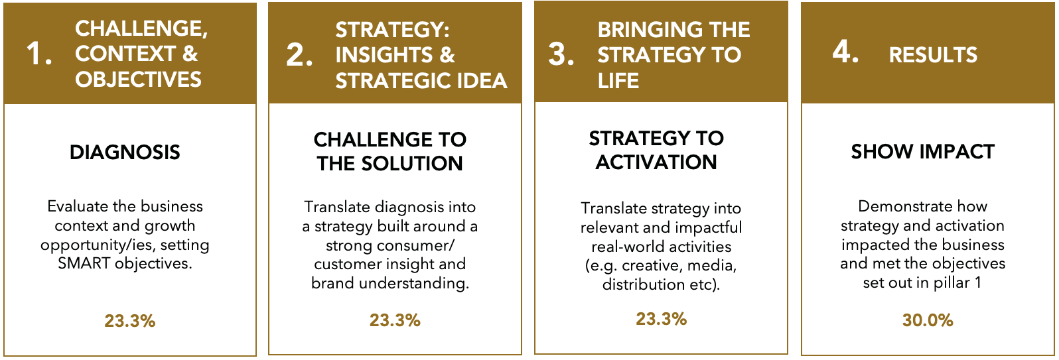
- Full written case. This is where you tell your marketing story across the four pillars of the Effie framework. The diagram below explains the four pillars, including the weighted scoring for each:
- Investment overview (an outline of what you spent and where, i.e. topline budgets for development/production and activation/media)​

The next few pages give an overview of each of the four pillars of the Effie framework to explain what’s required for each section.

1. Challenge, Context and Objectives

This section lays the foundations of your case. If it’s weak your whole entry will suffer, because it’s key to understanding how big your idea was and how impressive the results were. Weight will be given to the degree of difficulty of the challenge. Judges might not be familiar with your brand’s industry, so try to avoid jargon or acronyms.

QUESTION 1A
The context to your brand and business situation. Could include key competitor spend, position in market, category benchmarks, etc. Explain the characteristics of, or trends in, the market (e.g. government regulations, societal trends, weather/environmental situations). Frame what success looks like in your category.

QUESTION 1B
Judges look for clear objectives that aren’t retrofitted to match the results of the case. We ask you to outline your objectives across the following 3 types:
- Business: This should be the one key thing that you wanted to achieve for the business, the ultimate commercial objective that was being discussed in the boardroom. State it as clearly and simply as possible.
- Marketing: These should be directly linked to the customer or target audience in some way. Usually linked to a behaviour change: what did you want people to start doing/doing more of/doing less of/stop doing etc.? You can have up to 3 of Marketing Objectives.
- Campaign/Activity: What did you set out to change or reinforce through your activity? E.g. attitudes, perception, social discourse etc. You can have up to 3 of these objectives.

CATEGORY-SPECIFIC GUIDANCE

- Commerce & Shopper Cases: Include category/retailer growth objectives if applicable.
- Performance Marketing Cases: You may provide both pre-conversion objectives and conversion metrics. You must provide at least one conversion objective. Present the performance marketing goals and explain how these goals relate back to the overall brand or organisation’s strategy and objectives.
- Sustained Success Cases: It’s important to include change over time for both questions.

2. Strategy: Insights & Strategic Idea

This section asks you to explain the strategic thinking that enabled you to pivot from the challenge to your results.

QUESTION 2A
Explain who the target audience is and why they were the right one for your brand, bearing in mind your context, challenge and objectives. Outline if your target was existing, or new, or both. Describe them using demographics, culture, media behaviours, etc.
Commerce & Shopper Cases: Be sure to highlight the shopper’s motivations, mindset, behaviours, and shopper occasion.

QUESTION 2B
Outline your key insight(s) and how your audience’s behaviours and attitudes, your research and/or business situation informed them. Your insight(s) may be consumer, channel or marketplace based etc. Keep in mind an insight is not just a straight fact or observation, it should be something that’s unique to your brand and audience, which was leveraged to help meet your objectives.

Performance marketing cases: Your answer should include the data and audience insights that led to your strategy & idea. It could include one or more of the following:
- Non-data insights (e.g. behaviour observation, market research) that complemented your data insights
- Data analysis that provided the breakthrough in shaping your strategy
- New ways of identifying your audience and their search and purchase behaviour
- Marketing channel insights that underpinned your marketing channel mix

QUESTION 2C
The judges are looking for you to describe the core idea or shift you made that drove your activity and led to the breakthrough results. What was at the very heart of the success of this case? Please show how your thinking relates back to your insight and audience.
- Performance Marketing Cases: In addition to the above, your answer should bring to life your initial strategy and idea on how to target and convert your audience. Note: in Section 3 (Bringing the Strategy & Idea to Life), you can describe how you optimised or changed your strategy based on real-time performance.
- Sustained Success Cases: It’s important to include change over time

3. Bringing the Strategy & Idea to life

Judges are looking for a summary of the key elements of your plan, including your creative work and channel strategy. It’s important to help them understand how your plan relates back to your strategy and audience, and how the core components worked together to drive results. This section will be scored based on your answers, the information in the Investment Overview, and the assets you showcase in the creative reel and images.

QUESTION 3A
Explain how you activated your strategy. This may include one or more of the following: communications, brand experience, packaging, a product extension, a retail space (in store or stand-alone), a promotion,
sponsorship or partnership, CRM programme, search engine marketing, display advertising, affiliate marketing etc.

QUESTION 3B
Outline the key creative building blocks of the executions for your main marketing activation e.g. endline, call-to-actions, format choices, SEM copy, display ads, email copy and visuals, short or long videos etc.

QUESTION 3C
Your channel plan, with a clear rationale behind the choices you’ve made. Judges are looking to understand why you chose specific channels and how they relate to your strategy and audience. Explain how the different elements worked together to drive results.

QUESTION 3D
An opportunity to explain how the campaign evolved in response to market factors.

4. Results

Tie together the story of how your work drove the results. This section is key for a winning paper and accounts for 30% of the overall score to reflect its importance. Judges are looking for direct correlations between the objectives and the results of a case.

QUESTION 4A
Results must relate to your objectives and KPIs as outlined in Section 1.

- Explain how the results impacted the brand and the brand’s business. Why were these metrics/results important?
- Prove the results are significant using the category, competitive and brand context. You can provide context with historical data, industry benchmarks, competitors, etc so that judges can contextualise results.
- When providing engagement/social metrics in particular, detail what these meant for the brand and business/organisation.
- If you achieved additional results, explain what they were and why they are significant.
- When key metrics are withheld without explanation, judges may assume it’s because the results were weak.

QUESTION 4B
It’s important to make a compelling argument around why your marketing led to the results achieved, eliminating or attributing other factors that could have contributed to your success.

How to make your entry compliant

Your entry: Rules

The following could result in disqualification and the potential forfeiting of your entry fees: ​

Failing to adhere to the Effie Eligibility rules. Data presented must be isolated to the United Kingdom & work must have run at some point between 1/7/22 and 31/12/23. Results prior to the eligibility time period that help to provide context for judges to assess the significance of results achieved within the eligibility time period are fine to submit. Results that fall after the end of the eligibility period that are directly tied to the work that ran in the eligibility timing are also fine to submit. No work after the cut-off to the eligibility period should be submitted.
See the Eligibility section at the front of this document for further details & special exceptions.​

Entry does not meet category definition requirements. Entries are judged based on their effectiveness within the entered category. ​

Agency names/logos are included in the entry form or in the creative materials. The Effie Awards are an agency-blind competition, so no agency names should be included in the materials that judges review (entry form, investment overview, creative reel, creative images). An exception would be if the agency is the brand being entered and/or part of the campaign that ran publicly.

Data not sourced. All data, claims, facts, etc. should reference a specific, verifiable source. Sources should be as specific as possible, without citing specific agency names. Please give the source of data, type of research, and the time period covered. The entry portal is set up to encourage sourcing via footnotes. Please refer to the Sourcing Data page in this document for more information. ​

Directing Judges to External Websites. Entries are judged solely on the materials presented in the written entry and the creative examples supplied (creative reel + images). Entrants aren’t permitted to direct judges to websites for further information or for further examples of work.​

Missing Translation. All non-English creative work must include translation via subtitles or the Translation field on the Creative Examples tab on the Entry Portal. ​

Violating Creative Example (creative reel + images) Rules. Entrants should follow the guidelines outlined in the entry kit. Competitor logos/creative work and results may not be included in the creative examples, and time limits must be followed. See full rules, including guidelines on editing and content, in the Creative Requirements section of this document. ​

Your entry: Sourcing data

All data, claims, facts, etc. included anywhere in the entry form should include a specific, verifiable source. Entries that do not source data will be disqualified.​

On the entry portal, the entry form has a SOURCING box provided at the bottom of each scoring section for all references/footnotes. This allows entrants to provide sourcing without word limit restrictions.​ Here’s what you need to do:

- At the end of a sentence which includes a source, use the SUPERSCRIPT feature to number your sources.​
- In the Sourcing box, numerically list your citations. Suggested sourcing layout: Source of Data/Research, Research/Data Type, Dates Covered. ​

Judges cannot click on external websites when reviewing your entry, so if citing a website please also include key sourcing details (e.g. publication, article name, date).​

ADDITIONAL GUIDANCE​
- Because of Effie’s specific eligibility period, entrants are required to include the dates covered for all results data presented.​
- All data must be included in your response to Sections 1-4. Entrants may not add additional information or explanation in the sourcing section. The sourcing sections should only be used to provide citation.​
- Use the specific name of the company to reference a source except when the source is an agency (advertising, media or other). Because Effie is an agency-blind competition we require agency research to be referenced via the term “Agency Research.” This applies to all agencies, and is not limited to the entering agency. For increased specificity, entrants are encouraged to list the type of agency when applicable, e.g. “PR Agency Research”, “Media Agency Data”, etc. As with all other sourcing, include any relevant citation information (type of research/data, dates covered, etc.). Research companies should be cited by name, and judges encourage third-party data when available.​
- Effie Worldwide reserves the right to check all sources provided for accuracy.​

Your entry: Creative Reel

Your creative work is scored as part of Scoring Section 3: Bringing the Strategy & Idea to Life. ​

The focus of the reel should be the creative work. It shouldn’t be a case study video. You don’t need to feature all of the items selected in the touchpoints checklist (from the Investment Overview), only those integral to the case’s success that are explained in your written case. Any set-up (re: context, challenge) should not impede the judges’ ability to have this clear understanding. ​

​Your creative work is scored as part of Bringing the Strategy & Idea to Life. It is mandatory as part of your submission, along with creative images.

 | MUST INCLUDE​ |  | DO NOT INCLUDE​
- At least one complete example of each integral touchpoint, to ensure that the judges can see the breadth of the work you've described. It can be helpful to label each creative example by media type (“Outdoor”, “Social”, etc.)  - Video clips over 60 seconds may be edited down for time; but entrants are encouraged to keep as close to the original as possible  - If showing multiple examples of a touchpoint (e.g. 3x TV spots), after you show one example in full, it’s fine to edit down the additional examples for time |  | - Results of any kind or case summaries  - Agency names, logos, images  - Competitor creative work or logos. (Exception: permitted if competitor logos/work were included in your campaign materials.)  - Editing that will misconstrue what your audience viewed (e.g. changing the audio during a TV spot)  - Any confidential information, as creative reels will become public for finalists & winners.
 | SPECS​ |  | TALENT / LICENSING ​
 | - 1 creative reel per entry  - 4 minute maximum (Sustained Success entries can be 5 minutes)  - 250 MB maximum file size  - mp4 format  - High Resolution: 16:9 at 1920x1080.  - Do not include any agency names/logos in the video or in the file name. |  | - Do not add music/stock images that did not run in your original creative work to your reel unless you secure the rights to include those supplemental materials.  - Effie Worldwide is a 501(c)(3) non-profit educational organisation that shows work for educational purposes, and for honoring effective marketing ideas and the successful teams (client and agency) creating them. In our experience, as long as the talent/music were used in your original creative work, you should not run into an issue with rights/licensing.

Your entry: Creative Images

Images of the Creative Work: at least 2 images are required; a maximum​ of 6 images are allowed.

When the judges have read your case and watched the reel, they’ll review images of your work. The images uploaded should complement your reel and help the judges better evaluate the image-based creative elements of your marketing activity (e.g. website screens, print ads, logos, direct mail pieces, etc.). Or you may wish to upload work that you’d like judges to have another look at after watching the reel.

Technical Requirements: ​ ​
- .jpg format​
- High-res. 15 MB max
- Please don’t include agency names or logos on any creative materials (including file names) you submit

Creative images will be shown publicly if your case is a finalist or winner, for publicity and promotional purposes, so please consider how you would like it to be represented.

Other Requirements: Publicity

Entrants are required to provide the publicity materials below at the time of entry. These may be used on Social media, on-screen during the Awards Celebration and on Effie‘s website:
​
​
- LEAD AGENCY & CLIENT LOGOS​
Please provide current company logos for the Lead Agency and Client. Logos are not required for companies designated as Contributing Companies.​ These will appear on screen if you’re one of our winners, so please make sure the logos are current and hi res.
​Specs: ai/eps preferred; jpg/png also accepted.​
​
- CREATIVE EXAMPLES FROM JUDGING​
​The Creative Work provided for judging (reel + images) will also be used for publicity purposes.​
​

Other Requirements: Credits

We recognise that teamwork is needed to create an effective case, so this is where you should credit the creative and strategic partners who contributed – clients, agencies (full service, media, digital, promo, PR, event, etc.), media owners, retailers, etc.​

Client & Lead Agency credits are considered final at time of entry and can’t be changed after the entry is submitted. Therefore credits should be agreed with someone in senior leadership and approved via the Authorization & Verification Form, which can be downloaded in the Entry Portal after you have input all credits.​

Additions to company and individual credits will only be permitted after time of entry if your entry doesn’t already credit the maximum number. Credit changes after submission require a £250 fee to cover additional admin and can only be accepted up to 13th September 2024. All credit update requests will be reviewed and accepted at the discretion of Effie UK, but can’t be guaranteed.​

The table on the next page summarises the credits required/allowed:

Other Requirements: Credits

COMPANY CREDITS​ | INDIVIDUAL CREDITS​
Lead Agency (1 Required, 2 Maximum)​  Client (1 Required, 2 Maximum)​  Contributing Companies (0 Required, 4 Maximum)​  ​  CO-LEAD AGENCIES: You may credit a second Lead Agency and they will be given equal recognition by Effie. In order to be considered a second lead agency, you must certify that the work done by each agency was of equal weighting and each agency deserves equal recognition. Second Lead Agencies must be designated at time of entry, you may not add or remove second lead agencies after the entry period.​  ​  IN-HOUSE WORK: If you are an advertiser submitting in-house work, please list your company as both the Lead Agency and Client. ​  ​  Please confirm the spelling and formatting of other company names to ensure they’ll receive proper credit in the Effie Index and in all forms of publicity if your case is a finalist or winner. ​ | Primary Individual Credits (0 Required, 10 Maximum)​  Secondary Individual Credits (0 Required, 30 Maximum)​  ​  Primary Individual Credits will be used in situations where space is limited; otherwise all individuals will be listed in the credits.​  ​  Individuals credited on your case must be current or former employees of any one of the credited companies. ​

Confidentiality & Publication

The Effie Awards entry and judging process ensures the confidentiality of classified information.

JUDGING
Judging events have strict confidentiality protocols and are securely supervised by Effie moderators. Judges sign confidentiality agreements before judging begins and cannot save materials from judging sessions. Judges are individually matched with entries and categories that do not pose a conflict of interest.

INDEXING DATA
While judging is confidential and entrants may select publication permission for their written case, Effie understands some entrants may still have concerns regarding sensitive information. When presenting numerical data within the entry, entrants may choose to provide those numbers as percentages or indexes, so that actual numbers are withheld.

Additionally, unless the entrant opts to allow Effie to publish the entry as it was submitted if it becomes a finalist or winner, only judges will see the written entry as it was submitted.

CREATIVE WORK & PUBLICITY MATERIALS
The creative materials (reel, images, publicity materials) and case summary you submit into the competition become the property of Effie Worldwide and the Effie Awards and can’t be returned. By entering your work into the competition, Effie Worldwide/ the Effie Awards is automatically granted the right to make copies, reproduce and display the creative materials, case summaries, and statements of effectiveness within the context of your Effie entry for education and publicity purposes.

Creative work and case summaries may be on Effie Worldwide’s website, Effie UK website, partner websites, press releases/newsletters, programming/conferences and other events. Because materials for publicity and creative work will be published for all finalists and winners, no confidential information should be included in these elements. Please review the Creative Reel section of this document for more guidance on licensing/talent.

In extraordinary circumstances, Effie will review requests to submit an edited reel for publication. Such requests should be submitted to effieuk@effie.org if the case becomes a finalist, as non-finalist creative reels are only seen by judges and will not be published.

A note of reassurance
This year’s eligibility time period is 1st July 2022 to 31st December 2023 and the awards will be presented in November 2024. For some companies, this delay may alleviate some concerns regarding sensitive data.
Effie Board, Executive Staff, and Committee members are senior, well-respected professionals in the industry on both the client and agency side. If you are interested, we would be happy to set up a time for them to talk to you about confidentiality during judging; how to involve key team members in the judging process; and how you can submit indexed data. If you would like to have a further discussion about confidentiality, please email effieuk@effie.org.

Why your case is important
Effie Worldwide is a non-profit organisation on a mission to lead, inspire and champion the practice and practitioners of marketing effectiveness. To help us fulfil this mission and provide learning to marketers everywhere, Effie relies on entrants’ willingness to share their finalist and winning case studies. By providing permission to publish your written case you are:

- Showcasing your team’s success in achieving one of the top marketing honours of the year. Effie wins help to attract new talent and new business, prove the importance of marketing in business, and strengthen agency-client relationships.

- Helping to improve and support the industry and inspiring other marketers to raise the bar and make their marketing better.

Agreeing to the Publication Policy is one of the Terms & Conditions of entering the Effie Awards UK competition.

We respect that entries may have information deemed confidential. Within the Entry Portal, entrants are asked to set the publishing permission for their written entry. Entrants may select from the following options:

PUBLISH AS THE CASE WAS SUBMITTED | PUBLISH AN EDITED VERSION OF THE WRITTEN CASE
If you’re a finalist or a winner, you agree that your entry may be published as it was submitted and reproduced or displayed for educational purposes. | If you’re a finalist or a winner, you agree to submit an edited version of your case study for publication which will be reproduced or displayed for educational purposes. In this case, you may redact sensitive data in the following sections only: 1. Challenge, Context & Objectives and 4. Results .  Sensitive data that’s being redacted in these two sections should be replaced with indexed data instead - you can’t redact an entire section. A reminder will be sent out when this is required later this year.

The written case is the only part of the entry that should contain confidential information. The creative work (reel + images), public case summary, and statement of effectiveness should not include confidential information and will be showcased in various ways (effie.org, partner websites/publications), along with your public-facing written case, if your entry becomes a finalist or winner. Work submitted must be original or you must have the rights to submit it.

What happens next?

Judging

Your entry will be judged by some of the brightest and most experienced business leaders in the UK. Entries are judged in two stages: in both rounds judges evaluate the written case and creative executions. Scoring is done anonymously and confidentially. Judges provide written feedback on each case.

The finalist level and each winning level (gold, silver, bronze) have minimum scores which are required for an entry to be eligible for finalist status or for an award. This means it’s possible that a category may produce one or multiple winners of any level. or perhaps no winners at all – no matter the number of finalists. We don’t have quotas to meet to create one gold, silver and bronze winner in each category.

SCORING USING EFFIE’S EFFECTIVENESS FRAMEWORK

Judges are asked to evaluate specific criteria in scoring a case’s overall effectiveness and provide four separate scores analysing specific attributes of the work. In all rounds of judging, judges provide scores across the four pillars of the Effie Framework:

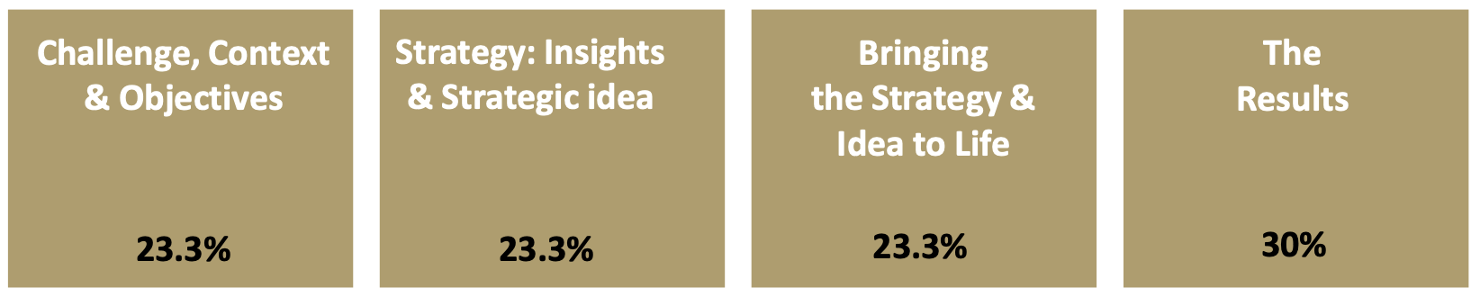

The written case is reviewed before the creative work. Judges discuss the case but score them individually.

JUDGING ROUNDS IN MORE DETAIL

Round One Judging
Judges individually review approx. 5-6 cases across a range of categories. Due to the volume of entries reviewed by each judge, brevity is encouraged. Cases that achieve the benchmark minimum score become finalists and move on to Final Round Judging.

Final Round Judging
As for Round One, all elements of each case are reviewed and scored to identify winners (and award levels). Judges review approx. 4 cases each.

The Grand Effie
The highest-scoring Gold Effie winners are eligible for the Grand Effie Award. The Grand Effie represents the single best case entered in a given year. As the Grand Jury is so senior and they express their collective opinion, the winning case represents both the most effective case of the year and a message that will be sent to the industry about lessons for the way forward. Only a select number of the highest-scoring Gold winning cases are considered contenders for the Grand Effie award.

We recommend nominating your senior client and agency team members for judging. Participating as a judge is one of the most valuable ways to learn about the awards, understand how judging works, and experience our security and confidentiality rules firsthand. Previous judges have also said how much they’ve enjoyed the opportunity to discuss great work with fellow marketers from different disciplines.

To nominate a judge, please complete our Judge Application Form.

JUDGES’ FEEDBACK
After this year’s winners are announced, we will automatically send all non-winning finalists a report outlining the judges' feedback on your case. This Insight Guide will help you to:

- Understand why your case achieved finalist status but didn’t win.
- Improve your future entries. Whether a case is a winner or not, there are lessons to be learned from the feedback the judges provide.

If you’d like to order an Insight Guide for an entry that won, or which wasn’t shortlisted as a finalist, please contact effieuk@effie.org. Please note that there will be an admin fee of £50 for this.

If you win

WINNING AN EFFIE

Founded over 50 years ago, the Effie Awards are a globally recognised symbol of outstanding achievement. Today, Effectiveness matters more than ever and the role that you and your teams play is critical in delivering growth and supporting our community. The awards honour all types of effective marketing as well as the people who make it, promoting the best work being made today and building a legacy of brilliant thinking that will inspire marketeers for years to come.

Finalist notifications will be sent in September 2024. These notifications will include additional information about how we will be celebrating their success. All winners and finalists will be recognised at the 2024 Effie UK Awards Celebration which will be held in London in November 2024.

EFFIE INDEX

The Effie Index (effieindex.com), the global ranking of marketing effectiveness, uses the credits submitted at time of entry to calculate the yearly rankings. Rankings include: Marketers, Brand, Agency, Independent Agency, Network and Holding Company.

If your case becomes a 2024 Effie finalist or winner, the submitted credits will be used to tally the Effie Index results. Because different point values are given to Lead and Contributing companies, it is critical that all brands and companies are properly credited at time of entry.

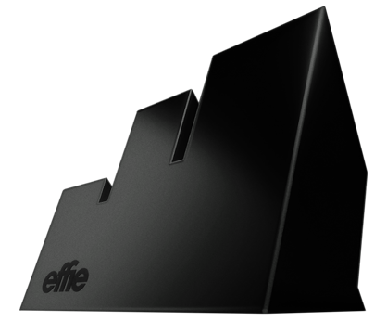


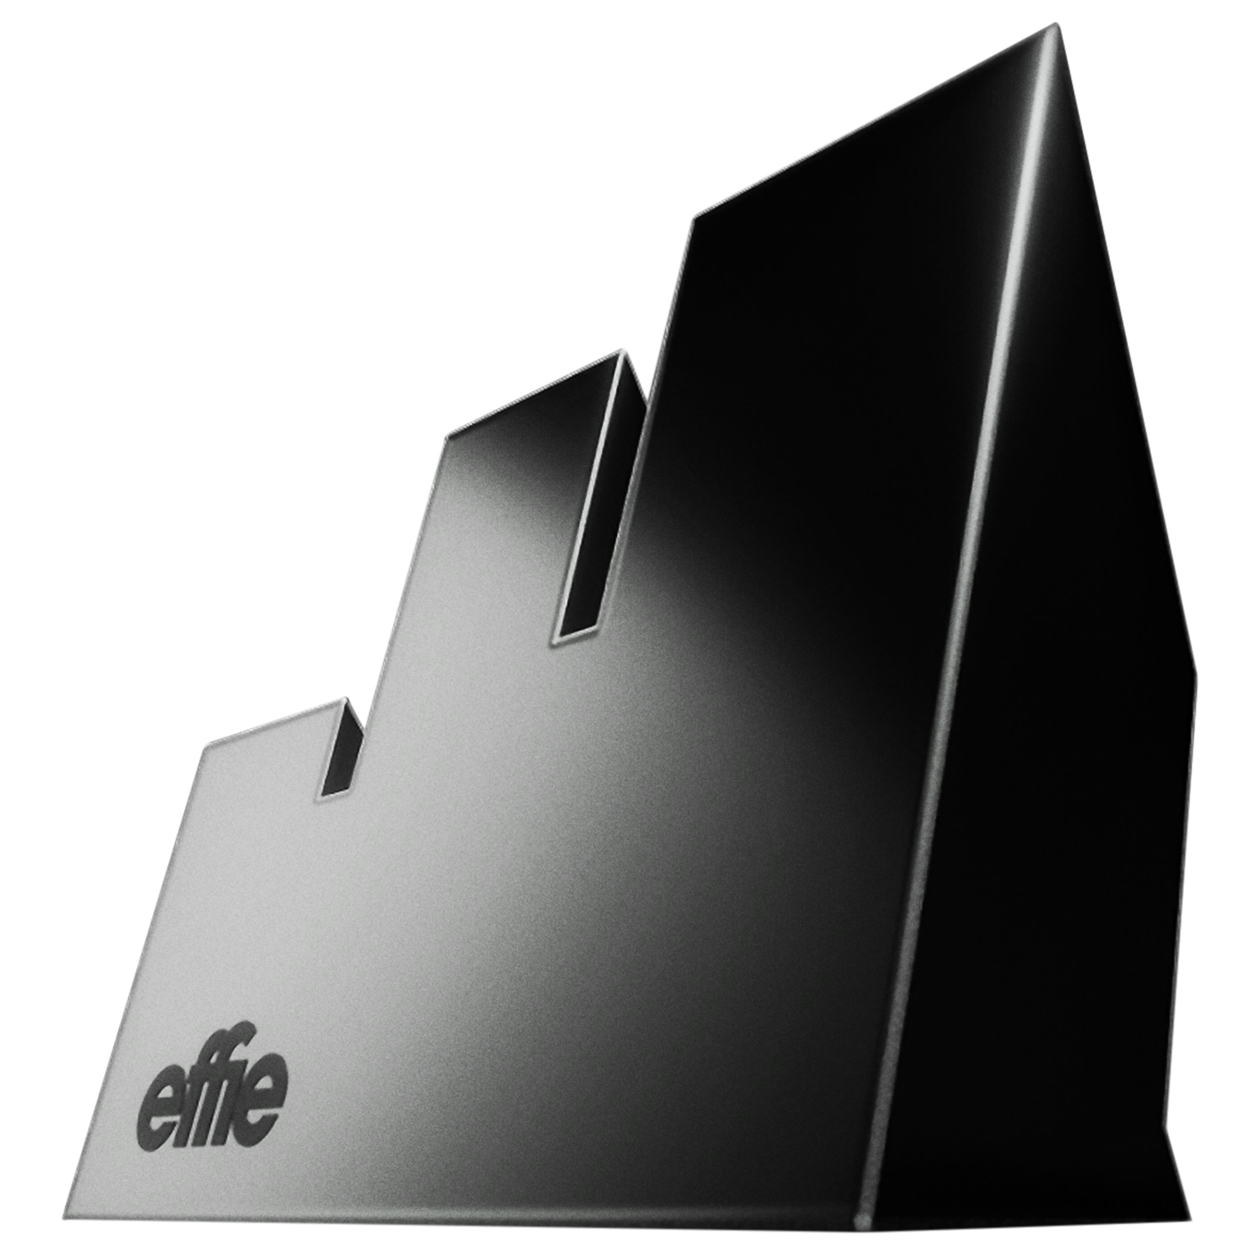

Appendix

Category overview (repeated from page 7)

BUSINESS CHALLENGES | INDUSTRY
Marketing Disruptors  New Product/Service Introductions (now includes product/service line extensions)  Renaissance  Seasonal Marketing  Small Budgets  Sustained Success: Products, Services  Timely Opportunity (formerly Seize the Opportunity)  Topical Marketing  Artificial Intelligence (AI) - NEW  Behavioural Science  Business-to-Business  Commerce & Shopper  Community Management  Corporate Reputation  Crisis Response/Critical Pivot  Customer Experience & Engagement  Media Strategy & Idea  Partnerships & Sponsorships  Performance Marketing  Social Media  Social Good – Brands  Social Good – Brands  Social Good – Non-Profit  Environmental – Brand  Environmental – Non-Profit | Automotive  Beauty & Personal Care  Beverages  Culture & The Arts  Delivery Services  Education & Training  Electronics  Entertainment & Sports  Fashion & Accessories  Finance  Food  Gaming & E-Sports  Government, Institutional & Third Sector  Healthcare  Hobbies, Leisure & Recreation  Home Goods & Services  Internet, Telecoms & Utilities  Media & Entertainment Companies (NEW)  Pet Care (NEW)  Professional Services  Restaurants  Retail  Software  Travel, Transport & Tourism  CATEGROY DEFINITIONS ON THE FOLLOWING PAGES.

Category definitions

BUSINESS CHALLENGE CATEGORIES

Marketing Disruptors. This award is for cases that grew their business / brand by changing the marketing model in ways that move the entire industry category they operate in forward. A marketing disruptor of any size can enter. You can be an established, new or emerging brand. The disruption can come from you:
- Making inroads against big, established brands
- Taking on ‘sleeping giants’
- Moving into a new product/service field beyond your current category and set of competitors to tackle a dominant leader
- Crafting your marketing model in a way that fundamentally changes the rules of the industry segment

Entrants must detail the business & marketing challenge, the competitive landscape and how they succeeded by changing the existing marketing model for the brand/category, and how that’s impacted on the whole sector in which they operate. Judges will deduct from your score if you do not sufficiently prove that your brand is a true marketing disruptor.

New Product or Service Introductions and Line Extensions. Any marketing case used to introduce an entirely new product or service, or a new extension of an existing product or service. Effie defines line extension as:
- Any variation of an existing product that shares the same brand name and is in the same category as the existing product, and shares the same characteristics as the parent but offers new benefit (flavour, size, package, type, etc.)
- A derivative product that adds or modifies features without significantly changing the price
- Products that bear the same brand name and offer the consumer varied options (e.g. Diet version of drink)

Note: Your entry must be written to address how your product/service or extension of either was new, and the situation you faced as a result of it being new. For example, what specifically was new? Why did the newness matter? Make sure you write your entry to reflect the category definition (new product/service introductions/line extensions).

Renaissance. This is an award for rebirth cases. To enter, your brand must have experienced a downturn of several years and a period of at least six months of upturned sales. The work being entered needs to have been the driver of renaissance, perhaps via a re-positioning or an alternative strategic approach. Entrants must detail the business challenge, the situation of the brand, the competitive landscape and how the activity drove success.

Note: Your entry must include the previous marketing investment and strategy as part of the context. Also, please provide details about the duration of the renaissance.

Seasonal Marketing. This category will honour work that effectively capitalised on a season, holiday or cultural event – key moments in the British annual calendar – to drive results for their business. Seasons, holidays and events allow marketers the opportunity to build strategic marketing activity based on the time-based interests of their target audience. Examples of key seasonal events are Christmas, Easter, Mother’s Day, Father’s Day, Valentine’s Day.

Small Budgets. Cases eligible for this category must represent the only marketing for this brand during the qualifying time period. To be eligible, an entry may not be for a line extension, a sub brand, or have an overarching brand campaign to support it. The value of donated and non-traditional media, as well as activation costs, must be included. This category is all about what you were able to achieve with a small media budget, rather than small production and creative budget. Budget eligibility is as follows:
- Local activity: £50,000 or less
- Regional activity: £200,000 or less
- National activity: £500,00 or less

Sustained Success*. Product or service marketing activity that has delivered sustained success for at least three years is eligible for entry.
At a minimum, you must include at least three years of creative work and case results, which must include the current Effie Award eligibility time period. Work must show consistency over the three years in both strategy and creative executions; with a continuation of core executional elements (e.g. spokesperson, song, theme, tagline, etc.). As part of your entry, specifically address how the work evolved over time (e.g. media choices, targeting, insights, new products/services, etc.). Answer all questions for the initial year and describe how/why change occurred over time.
You have a choice of 2 sub-categories: Sustained Success – Products or Sustained Success – Services.
*A separate entry form and different creative requirements are required for the Sustained Success category.

Timely Opportunity. This category is looking for those brands that had the insight to know how and when to ‘throw a stone into a pond’ and maximise the ripples it created. Cases entered into this category will show how to put a brand or product/service in an intensely bright spotlight to create immediate and measurable impact.
Winners will represent those who had the insight and creativity to craft unexpected and unconventional moments for a brand. The best examples will see live experiences, moments, stunts, and tactics, online & offline, perhaps amplified through PR, social media, digital engagement, or even the use of content created in the moment, to fuel paid campaigns.
This category spotlights marketing that was able to generate real desired results as a direct outcome from a single significant moment of activity.

Topical Marketing. This category is for cases that effectively leveraged immediate relevance, interest or importance via a targeted marketing strategy around current events (e.g. elections, World Cup, Olympics, economics, etc.)
Annual events should enter the Seasonal Marketing category.

SPECIALITY CATEGORIES
Artificial Intelligence (AI) – NEW. This category aims to recognise the use of AI technology to enhance marketing effectiveness. This includes audience targeting, interactive experience, programmatic, creative development, content generation and innovation. Entrants should illustrate how AI drove effectiveness, from initially motivating audiences to ultimately driving behaviour change.
Behavioural Science. This category is about recognising marketing activity inspired by behavioural science. To be eligible to enter into this category you need to provide specific details that your strategy was influenced by behavioural science. You need to explain clearly how you went about pinpointing the behavioural bias that was the inspiration behind your approach. Tell us what levers you used to then apply the learnings and insights from this behavioural bias to instigate or change an audience behaviour to your advantage to achieve your objectives.

Business-to-Business. This category is for marketing activity from businesses targeting other businesses. Business-to-business cases for any type of product or service from any marketplace segment are eligible to enter.

Commerce & Shopper. This category recognises the most effective integrated marketing activity designed to engage the shopper and guide the purchase process - online and/or in-store. Eligible cases include those for single or multiple brands, and/or for a category. All media channels are eligible for inclusion: mobile, digital, TV, video displays, magazines, social media, sampling programs, in-store signage and displays, etc. Entrants must show how the work effectively connected with the shopper, influenced them along the path to purchase, and inspired them to buy.

Community Management. This category is about managing effective, engaged communities. Entrants will be brands that are creating content, experiences, platforms, news, etc. that get their communities to grow, engage, share and act. Entrants will need to state clearly how they managed the community, how they defined effectiveness around the community, what they specifically achieved, and why the engaged community was significant for the development of the brand/business.

Corporate Reputation. This category is for cases that promote corporations, not exclusively their products, and it might include sponsorships, image & identity and PR. In addition to presenting metrics related to reputation, entrants are encouraged to also address how these metrics relate to the corporation’s business and/or brand, and why they are important.

Crisis Response/Critical Pivot. This award is for brands that effectively pivoted their marketing programme or business activities in response to significant structural and cultural shifts and/or moments of crisis (e.g. cost of living crisis, social justice movement, political events, etc.). These shifts can be internal to the business or external. Entrants will need explain the shift to the judges, show how it has impacted the business, frame how the approach has changed in response, and how has the marketing strategy adjusted to secure a successful outcome for the business/brand. It will be important for entrants to demonstrate the effectiveness of the action for the brand. Examples can include a pivot in positioning, a change in portfolio management, a digital acceleration, etc.

Customer Experience & Engagement. This category showcases work that delivered customer engagement and experience beyond traditional communications. We expect to see evidence of a new initiative that successfully drove engagement with your customers, whether that be a complete overhaul of your CRM programme, or a one off experience with a specific objective. The activity can be virtual or tangible – e.g. you may have re-invented a product demo, re-imagined the pop-up store, led a bricks and mortar retail overhaul, redesigned your customer on-boarding or service journey, or you might have created a game or interactive film experience to showcase a new product or brand personality – it could be anything. You should demonstrate how you reached out to your audience to deliver a memorable, engaging experience and build a meaningful connection to drive results. Judges will want to understand the ‘participation’ in the experience as a key factor.

Media Strategy & Idea. This category recognises cases driven by media thinking. The award honours media-led strategic thinking and ideas that are powerful enough to become the genesis of the marketing programme itself. The line between what constitutes a creative idea and a media idea is blurring; there are occasions when the media idea or media strategy drives the entire marketing effort – some examples include:
- Media Strategy – cases where media planning spearheaded the effort
- Content Led – cases led by a content idea
- Data Driven Insights – cases led by a data driven insight
- Tech Led – cases led by a technology idea
- Media Idea Led – cases led by a Media Idea other than those listed above

Partnerships & Sponsorships. This category is for marketing activity centred around partnerships and/or sponsorships. Entrants are required to provide information on the nature of the partnership/collaboration/sponsorship and the strategic rationale/fit behind it, as well as evidence that it was this partnership/sponsorship that led to effective results and delivered your objectives. Partnerships & sponsorships can be between two brands or between a brand and an individual e.g. an influencer/public-life personality. This partnership/sponsorship can be part of a wider marketing programme or a standalone activity, and the entrant needs to make this clear in their entry.

Performance Marketing. This category recognises the most effective performance marketing cases. Performance marketing refers to online marketing and advertising programmes in which advertisers (a.k.a., “retailers” or “merchants”) pay marketing companies (a.k.a, “affiliates” or “publishers”) when a specific action is completed, such as a sale, lead or click. Key performance marketing channels include native advertising, sponsored advertising, affiliate marketing, social media advertising and search engine marketing. To enter your activity must be led by performance marketing and you must demonstrate how what you did drove results for the business using performance marketing practices and KPIs.

*A separate entry form and different creative requirements are required for the Performance Marketing category.

Social Media. This category is for cases that set out with the explicit purpose of using social as the primary touchpoint or have social at their heart. The kind of idea that is specifically designed to take advantage of the socially connected consumer and the influence of social. This could include activity that effectively worked with key influencers to reach their target audience to achieve short or long-term marketing goals.
Judges are looking for marketing that begins with a social idea, as opposed to advertising or integrated campaigns with a social media element. You will need a clear rationale for why social was the right way to tackle the brief, and evidence of how social activity measurably and materially drove the commercial result. It’s not enough to count the number of impressions, likes or shares; you will need to measure and prove the commercial value of social through the direct effect it had on audience behaviour or perceptions and demonstrate correlation with the achieved business results.

INDUSTRY CATEGORIES

To recognise effective marketing for products and/or services for brands and businesses operating in a particular industry:

Automotive. Includes vehicles as well as aftermarket. Vehicles includes cars, trucks, motorcycles, vans - both brand and model marketing. Aftermarket includes petrol, motor oil, tyres, batteries, paint, quick-lube, oil change, muffler, transmission, windshield wipers, enhancements, etc.

Beauty & Personal Care. Products and services focused on beauty, which includes cosmetics, fragrances, hair care, nail products, etc. and beauty services such as salons, spas, etc. Personal care products such as soap, dental products, face & body lotions and cleansers, cotton swabs, deodorants, feminine hygiene products, razors, shaving cream, etc. are also included.

Beverages. Includes alcoholic as well as non-alcoholic drinks. Alcoholic beverages are beer, champagne, spirits, wine, wine coolers, after dinner drinks, etc. Non-alcoholic beverages are diet and non-diet sodas, coffee, tea, juices, squash, milk, milk substitutes, bottled water, sparkling water, energy drinks etc.

Culture & The Arts. Plays, museums, immersive experiences, music organisations and festivals, concert series, cultural festivals, theatre festivals.

Delivery Services. Couriers, package/freight shipping, food & drink delivery, grocery delivery, flower/gift delivery, overnight delivery, package racking, international service, etc.

Education & Training. Includes all educational organisations and institutions, training programmes, job/career sites, etc.

Electronics. TVs, radios, mobile devices, home entertainment, laptops, tablets, cameras, smart home devices, computer hardware, game consoles, drones, external or integrated VR/AR devices, sound systems, etc. Electronic devices may be aimed at consumers or businesses.

Entertainment & Sports. Includes all forms of entertainment, including films, TV shows, radio shows, podcasts, books, music, comics, games, toys, entertainment apps, etc. Sporting events such as Wimbledon, the Ashes, Six Nations, sports teams, etc.
Note: Please see the new Gaming & E-Sports category for video games.

Fashion & Accessories. Includes all clothing, accessories, jewellery, styling services, clothing rentals, etc.

Finance. Financial products and services including overall corporate/brand image and capabilities of a financial institution, or specific products or services (including current and savings accounts, credit/debit cards, reward/loyalty cards, financial planning, mobile payment services, retirement funds, investment, home banking, loans, mortgage, mutual funds, insurance products, banking apps etc).

Food. All food, whether fresh, chilled or frozen and packaged; foods both regular and diet/light. Also includes snacks and desserts such as ice cream, confectionary, crisps, cakes and biscuits, bakery items, nut, fruit & vegetable snacks, popcorn, etc.

Gaming & E-Sports. All forms of e-sports and single and multi-player video games, including virtual reality, arcade, console, mobile, online and computer games.

Government, Institutional & Third Sector. Local, regional and national government and its various departments - such as health, armed forces, transport etc; educational institutions/organisations; NGOs & charities sector; trade bodies and their efforts focusing on economic development, membership drives, recruitment drives, public good messages etc. Includes political messages and special interest/trade group marketing activity.

Healthcare. Health Products and Services are both eligible to enter this category. They may be targeted to healthcare professionals, patients and/or consumers, or both. Includes products that are sold without a prescription which address specific health conditions (‘Over-The-Counter’); products that are sold through a prescription; marketing developed for health services or healthcare professionals. Products and services that address a specific health condition should enter this category – there are separate categories for Beauty & Personal Care and Hobbies, Leisure & Recreation cases.

Hobbies, Leisure & Recreation. Products and services aimed at hobbies, leisure, and recreation, including, but not limited to: dating services/apps, wedding planning platforms, personal development/improvement programmes/apps, genetics/ancestry testing services, sporting and camping goods/services and other items/services intended for leisure activity. Also includes products/services focused on consumer health and/or promoting a healthy lifestyle, fitness & wellness. Includes digital health products, fitness trackers, health/fitness apps, exercise equipment, nutraceuticals, vitamins, energy bars and drinks, etc; fitness studios; weight loss and fitness programs/camps, training camps and facilities, etc.

Home Goods & Services. Includes furnishings & appliances, such as kitchen and laundry appliances, air conditioners, carpeting, furniture, decorator’s supplies, paint, wallpaper. Also includes household supplies & services, such as cleaning products, waxes, detergents, floor-care products, fabric softeners, paper products, domestic services, mowers, fertilisers, lawn care, gardening services.

Internet, Telecom & Utilities. Mobile network providers, high speed Internet access services, online services, portals, search engines, bundled communications (internet, telephone, and TV). Fixed telephone line providers. Utilities such as electricity, gas, alternative fuel.

Media & Entertainment Companies: TV networks, streaming services, websites (entertainment, lifestyle, news, trade, etc.), magazines, newspapers, consumer or trade media, radio stations, broadcasters, etc.

Pet Care: Animal care products and services of all types, including food, toys, veterinary and boarding services, training, breeders.

Professional Services. Includes services such as accounting, consulting, legal, staffing, recruitment, property/real estate/estate agency, domestic and commercial services, etc.

Restaurants. Quick service, casual dining, mid-scale, white tablecloth and other restaurants. Any type of restaurant may enter.

Retail. Open to all retail / e-tail / mail order companies with general or specific merchandise. E.g., department stores; online retailers; clothing, fashion, shoes or jewellery stores and food retailers; film/book stores; discount/bulk retailers; pet care; toy stores; greeting cards; craft stores, etc. Also includes fashion brands & designers selling direct to consumer such as clothing, jewellery, handbag, accessories, shoes, eyewear designers.

Software. Software, groupware, operating systems, SaaS/IaaS and Cloud based services, software/apps stored locally on a computer/tablet/mobile device, etc.

Travel, Transport & Tourism. Air, train, bus, taxi, rideshare services, subway systems, bike/scooter shares, car rentals, ferries, etc. Cruises, hotels, resorts, amusement parks, travel websites and booking services, travel tours, tourism campaigns, etc.

POSITIVE CHANGE CATEGORIES

Environmental Track

The Positive Change: Environmental category celebrates cases that have measurably shifted audience behaviour toward more environmentally sustainable choices, and/or grown demand for more sustainable products and services by incorporating environmentally-conscious messaging into their marketing.

Winners of this award will need to demonstrate how effective marketing progammes that incorporate sustainable strategies can make a positive difference for brands and for the environment. Entries must have as one of their main strategic objectives changing audience behaviour towards more environmentally sustainable choices, and environmentally conscious messaging must be part of the marketing. Entrants should also address how the sustainability goal relates back to the overall brand and business strategy. Judges will be looking for evidence of behaviour change toward more environmentally sustainable choices, with these elements being considered:
- Awareness – Making the audience aware of a sustainable product, service or action
- Trial – Trying the sustainable product, service or action for the first time
- Product/Service Substitution – Switching to a more sustainable product, service or action
- Change in Use – Using a product/service more sustainably than before or taking a more sustainable action
You can enter your case into one of the following categories:

Environmental – Brands. Recognising brands with marketing programmes that have measurably shifted audience (B2B or B2C) behaviour toward more environmentally sustainable choices, and/or grown demand for more sustainable products and services by incorporating environmentally conscious messaging into their marketing.

Environmental – Non-Profit. Recognising non-profit organisations and associations with marketing programmes that have measurably shifted audience (B2B or B2C) behaviour toward more environmentally sustainable choices, grown demand for more sustainable products and services, and/or measurably drove positive impact for their cause by incorporating environmentally conscious messaging into their marketing.

Social Good Track
The Positive Change: Social Good category celebrates cases with proven effectiveness in addressing a social problem or in expanding an existing programme in ways that benefit our society. This is about creating positive societal and cultural change, challenging the established status-quo and smashing accepted norms and stereotypes that create societal inequalities. Examples include initiatives that tackle food poverty, access to healthcare & education, creating a more diverse and inclusive society, creating equal opportunities at work and in wider society for all members of our society.

Any marketing that sets out to give back in some way for the greater good is eligible to enter. Any and all marketing efforts, whether full campaigns or distinct elements within a campaign are eligible to enter, as long as measurable results exist.

You can enter your case into one of the following categories:

Social Good – Brands: Recognising brands that are making the world a better place by using the power of their marketing platforms for good. This category celebrates for-profit brand efforts that effectively combined business goals with a social cause (health, education, community, family, etc) and successfully related that cause back to the company’s overall brand strategy, resulting in positive business and social impact.

Social Good – Non-Profit: Recognising non-profit organisations and associations whose marketing has effectively driven positive change for society and successfully contributed back to the organisation’s purpose. Campaigns must show measurable impact and proven results in support of the cause.

Contact us

QUESTIONS ABOUT YOUR ENTRY
For any questions regarding the entry process, materials, categories, rules, etc., contact: effieuk@effie.org .

CASE DATABASE & SUBSCRIPTIONS
The purpose of the case database is to educate about effective marketing and to showcase the companies and individuals creating effective work to enhance learning in our industry. Take a look at what the Effie case database has to offer here. For more information email our dedicated team on subscriptions@effie.org.

JUDGING
To apply to be an Effie Judge, please complete the Judge Application Form. If you have questions about the judging process, email effieuk@effie.org

EFFIE INDEX
The Effie Index identifies and ranks the most effective agencies, marketers, brands, networks, and holding companies by analysing finalist and winner data from Effie Award competitions around the world. Announced annually, it is the most comprehensive global ranking of marketing effectiveness. For more information email us at index@effie.org

Thanks – and good luck with your entry!

